GOOD HOPE SINGERS “SEASONS OF LOVE” CONCERT
JOIN US TO HELP CHILDREN IN NEED

Step 1: Complete and email this form to Judy Wong at sponsors@goodhopesingers.org
Step 2: Mail back this form together with a cross cheque on or before 8th January, 2011 to:
  - Good Hope Singers Limited, 383 Jat’s Incline, Kowloon
  - Cheque should be made payable to “Good Hope Singers Limited”
  - Write your name and contact number at the back of the cheque

Submission deadline: 8th January, 2011
For enquiries, please call Judy Wong at 852-9670 5460.

I would like to purchase Seasons of Love Concert tickets¹ with details as following:
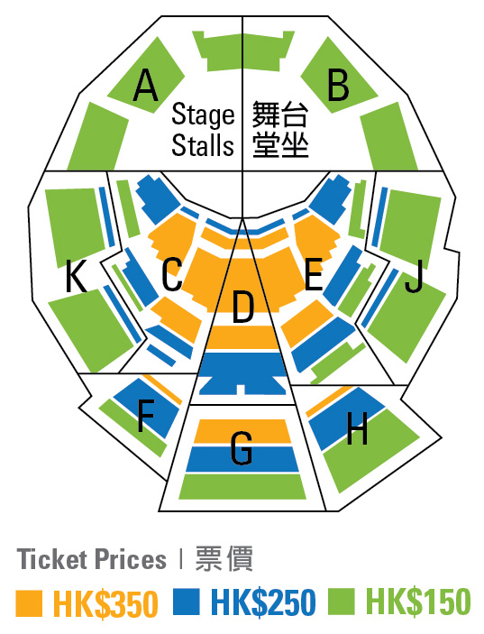
Advance Ticket Booking Only Available Till 8th January, 2011
Ticket Price (in HK$) | Number of Ticket | Total (in HK$)
$350 |  | $
$250 |  | $
$150 |  | $
Grand Total |  | $

I would like to advertise² in the Seasons of Love Concert Programme.

Page Size | Unit Cost (in HK$) | Put “X” as appropriate
Full Page | $8,000
Half Page | $5,000

I would like to make a donation² of HK$

My Personal Details

Name: Mr / Mrs / Ms

Correspondence Address

Email Address

Name on tax deduction receipt² (if different from above)

Mobile Number Office Number

Total Payment of HK$ cross cheque³ is enclosed.

Signature ____________________________________ Date
(Signature not required when sent via email)
Notes:
- Ticket sale will be available to public at all Urbtix outlets starting 2nd January, 2011. Purchased tickets will be available for collection 1 hour before the concert at the reception desk. Identify yourself with the name registered above
- Tax deduction receipt will be issued by Good Hope Singers for any donation of HK$100 or above. It will be directed and sent to the name & corresponding address registered
- An acknowledgement email will be issued upon receipt of the cheque

