GOOD HOPE SINGERS “MY RAINBOW” CONCERT

Proceeds from the Concert will be used to sponsor Music Therapy sessions for children with special needs.

Step 1: Complete and email this form to Yvonne Lo at sponsors@goodhopesingers.org
Step 2: Mail back this form together with a cross cheque on or May 10th, 2012 to:
  - Good Hope Singers Limited, 7 Silver Stream Path, Clear Water Bay N.T.
  - Cheque should be made payable to “Good Hope Singers Limited”
  - Write your name and contact number at the back of the cheque

Submission deadline: May 10th, 2012
For enquiries, please call Yvonne Lo at 852-6113-8804.

I would like to purchase My Rainbow Concert tickets¹ with details as following:
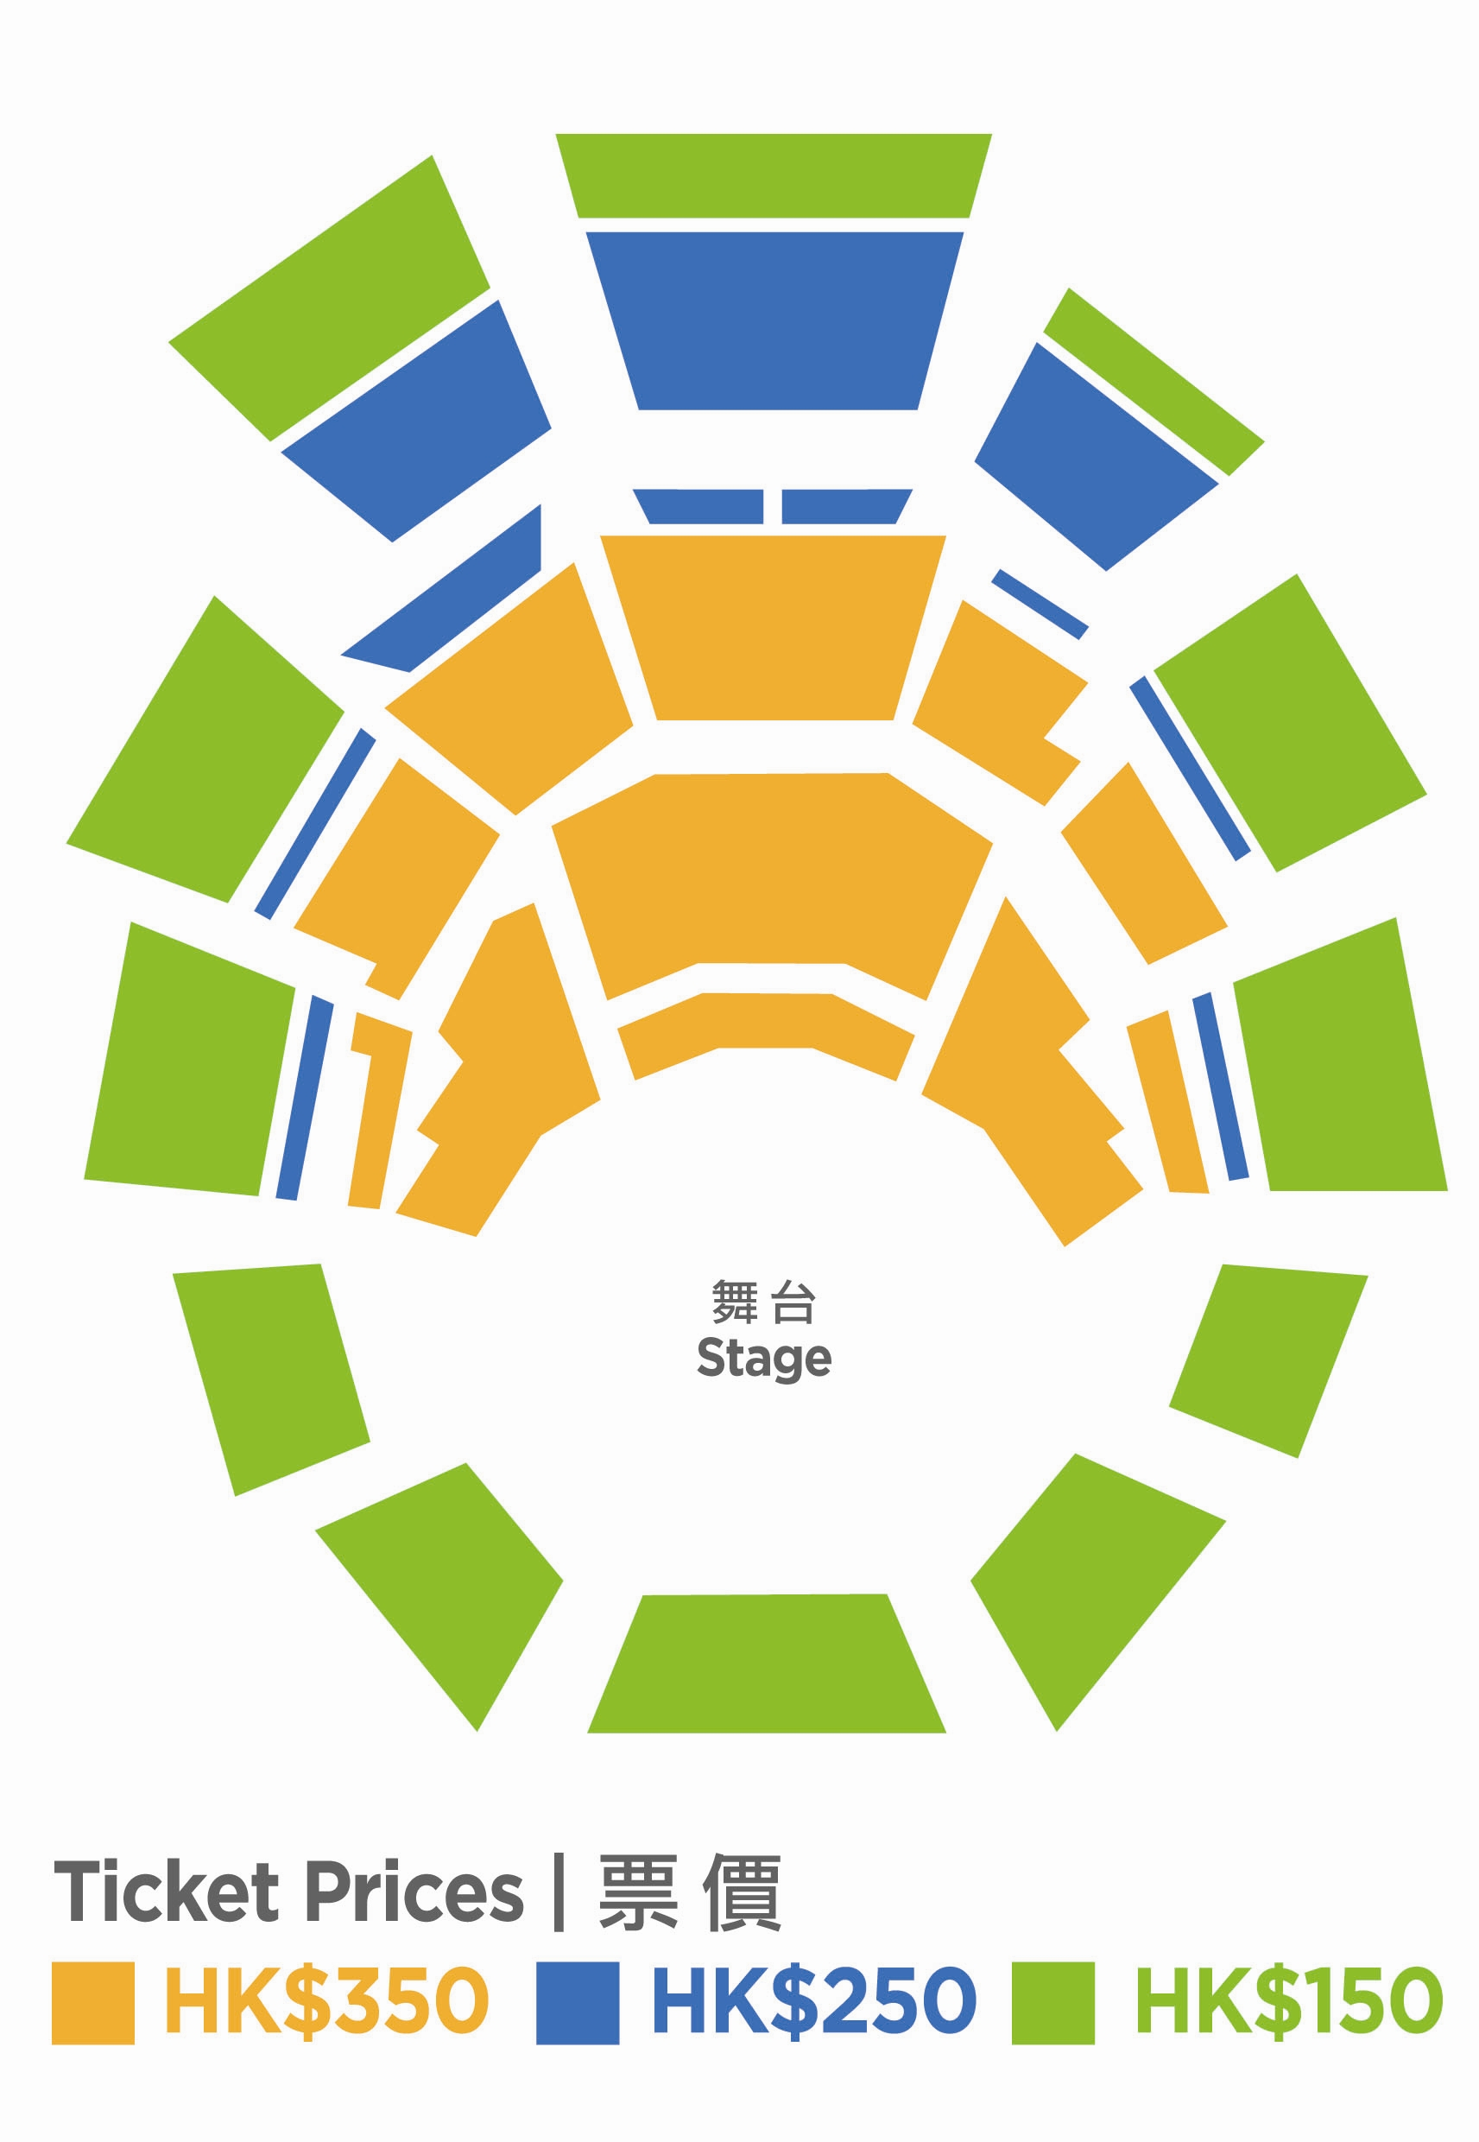
Ticket Booking Only Available Till May 10th, 2012
Ticket Price (in HK$) | Number of Ticket | Total (in HK$)
$350 |  | $
$250 |  | $
$150 |  | $
Grand Total |  | $

I would like to advertise² in the My Rainbow Concert Programme.

Page Size | Unit Cost (in HK$) | Put “X” as appropriate
Full Page | $8,000
Half Page | $5,000
¼ Page | $2,500

I would like to make a donation² of HK$

My Personal Details

Name: Mr / Mrs / Ms

Correspondence Address

Email Address

Name on tax deduction receipt² (if different from above)

Mobile Number Office Number

Total Payment of HK$ cross cheque³ is enclosed.

Signature ____________________________________ Date
(Signature not required when sent via email)
Notes:
- Tickets are also available for sale on 26th April, 2012 in all URBTIX outlets. Purchased tickets will be available for collection 1 hour before the concert at the reception desk. Identify yourself with the name registered above
- Tax deduction receipt will be issued by Good Hope Singers for any donation of HK$100 or above. It will be directed and sent to the name & corresponding address registered
- An acknowledgement email will be issued upon receipt of the cheque

